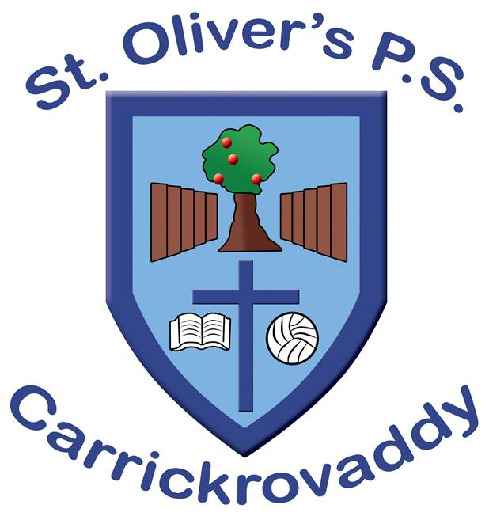

personal development and mutual understanding Policy (PDMU Policy)

“PDMU focuses on encouraging each child to become personally, emotionally, socially effective, to lead healthy, safe and fulfilled lives and to become confident, independent and responsible citizens, making informed and responsible choices and decisions throughout their lives.” (NI Curriculum)

PDMU is an area of learning that focuses on children’s emotional development, health and safety, relationships with others and development of moral thinking, values and actions.

RATIONALE
In St. Oliver’s P.S. we recognise that we are living in a period of rapid and often dramatic social, economic and technological change. In this climate our young people should ideally develop intra-personally and inter-personally through the role models of significant adults in their lives. As a result, they will become more emotionally intelligent and recognise the importance of having the right values and practices in the employment of life skills. We recognise the role teachers play as facilitators, providing young people with the knowledge and opportunity to practice vital life skills.
With the ongoing COVID 19 pandemic and its impact on schools, there has been a great onus put on the importance of catering for the mental, emotional and physical health and wellbeing of school children. A comprehensive PDMU programme is essential to meet the growing needs of children during this uncertain time.

AIMS

As a Catholic school, in line with our ethos and values, it is our view that the personal development of our young people is as important as their academic development. We believe that the holistic approach to development on all levels produces well-rounded “whole” people, equipped with the skills to deal with life. In recognition of this, when delivering the personal development programmes, we focus on the development of skills and values centred firmly on the person.

Through PDMU we aim to:
- Create a more open relationship between staff and children.
- Raise standards of achievement by children who feel more secure, motivated and confident and who are independent learners.
- Improve the health and well-being of children in our care.
- Provide a more inclusive environment, where all are valued and have a voice.
- Contribute to our local community as responsible citizens who have a sense of personal and social responsibility; have positive and healthy behaviours, including a concern for others and the environment; are open to new ideas and have integrity and moral courage.

OBJECTIVES
Through the delivery of the Personal Development and Mutual Understanding (PDMU) programme, our young people should be able to:

- develop skills, attitudes, values and abilities which will enable them to be effective in a variety of adult situations and occupations.

- develop knowledge and understanding of themselves and others as individuals – their strengths and limitations, abilities, skills, personal qualities, potential, needs, attitudes, and values.

- develop independence of mind and take responsibility for their own decisions and actions.

- develop self-reliance, self-discipline, self-respect and self-esteem.

- adopt an enterprising and persistent approach to tasks and challenges.

- develop a respect for ways of life, opinions, and ideas different from their own, provided these are based on consideration and respect for others.

- develop a concern for and a readiness to act on behalf of others who cannot effectively act for themselves.

- develop knowledge and understanding of the world in which they live and of employment and other opportunities that are available.

- gain a concern for conservation of the natural world and the environment.

- become effective independent learners.

HOW IT WILL BE DELIVERED
Several strategies will be used. These include:

- Personal Development and Mutual Understanding will be delivered as an individual subject area with time set aside on each class’s weekly timetable.
- It will also be developed through all other areas of the Curriculum and will help support all aspects of teaching and learning.
- Teachers will deliver PDMU by using the nine strands throughout the school year to develop all areas within the Living. Learning. Together Programme.

METHODOLOGY AND LEARNING APPROACHES
- In recognition of the fact that we all learn in different ways, a range of learning styles and teaching strategies will be employed related to active/experiential learning. These approaches will emphasise group and collaborative strategies, maximising opportunities for pupil input, decision-making and problem-solving.

- Lessons will be conducted in a non-judgemental atmosphere with the teacher in the role of the facilitator, creating and maintaining a safe and secure environment. Empathetic relationships based on mutual respect will be developed to create a place where fears and concerns can be expressed openly without risk of ridicule or reproach.

- The delivery of lessons will be concerned with the systematic and purposeful development of the whole person with emphasis on the active involvement of pupils in the learning process.

Teachers will use a wide variety of methods to support PDMU lessons throughout the course of each year. The table below shows some example of these methods.

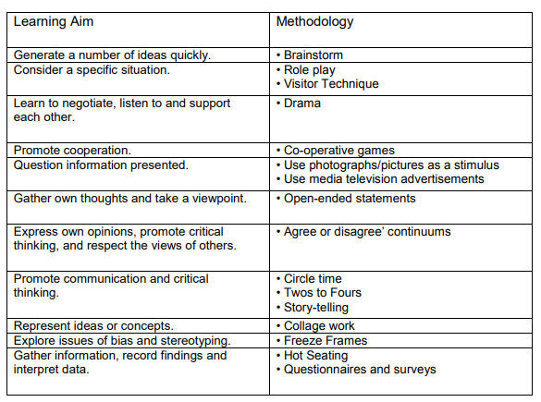

PDMU IN NI CURRICULUM

PDMU is one of the six areas for learning in the Northern Ireland Curriculum. In the Foundation Stage, Key Stage One and Key Stage Two it is divided into two strands:
- Personal Understanding and Health
- Mutual Understanding in the Local and Wider Community

Children are expected to acquire skills and knowledge from nine themes within these two strands:
Strand One: Personal Understanding and Health
1. Self-awareness
2. Feelings and Emotions
3. Learning to Learn
4. Health, Growth and Change
Safety

Strand Two: Mutual Understanding in the Local and Wider Community
5. Relationships
6. Rules, Rights and Responsibilities
7. Managing Conflict
8. Similarities and Differences
9. Learning to live as members of the community

These themes are explored and developed in a cumulative manner as they are revisited in each Key Stage through Topic work, Circle Time and the ‘Living, Learning Together’ packs.

*OUTLINE OF THE PDMU PROGRAMME DELIVERED IN EACH KEY STAGE*

- FOUNDATION STAGE (P1/2)
PDMU CURRICULUM – USING ‘Living, Learning Together’ programme for Year 1 and Year 2 (rolling).

THEME 1: MYSELF/SELF-AWARENESS
Explore themselves and their personal attributes (Red Unit). Similarities and differences (Indigo Unit).

THEME 2: FEELINGS AND EMOTIONS
Explore their feelings and the feelings and emotions of others (orange unit)
- Recognise feelings and name them
- know what to do if sad, afraid
- what makes us sad, angry
- tell others, talk about feelings.

THEME 3: HEALTH AND SAFETY
Explore how to keep safe in familiar and unfamiliar environments (yellow unit)
- Be aware of caring for our bodies
- Be aware of good hygiene practices
- Personal safety strategies
- Road safety
- Rules about medicines
- Be aware of growth and change
- Healthy eating/keeping bodies safe and healthy

THEME 4: RELATIONSHIPS
Explore relationships with family and friends (green unit) and belonging and getting along with others.
- Family, what we do together
- Special people in families
- Friends in school and at home
- What they do together, how they relate to each other
- How to treat their family and friends correctly.

THEME 5: RULES, RIGHTS AND RESPONSIBILITIES
Explore co-operating with others, necessity of rules in classroom and school, a sense of fairness and resolving conflict situations (Blue Unit)

THEME 6: LEARNING TO LIVE AS MEMBERS OF THE COMMUNITY
Explore the independent nature of the class/school community – how we can work well together (Violet Unit).

- KEY STAGE 1 (P3/4)
PDMU CURRICULUM using ‘ Living Learning Together’ Programme for Year 3 and 4 (rolling)
THEME 1: SELF-AWARENESS
Pupils are given opportunities to develop knowledge, understanding and skills in developing their self-esteem and self-confidence.
- Feel positive about themselves and develop an understanding of their self-esteem and confidence.
- Become aware of their strengths, abilities, qualities, achievements, personal preferences and goals.

THEME 2: FEELINGS AND EMOTIONS
Pupils are given opportunities to explore their own and other’s feelings and emotions and how their actions affect others.
- Begin to recognise, name and manage their feelings and emotions and realise that they are a natural, important and healthy part of being human.
- Begin to recognise and manage the effects of strong feelings such as anger, sadness or loss.

THEME 3: LEARNING TO LEARN
Pupils explore how positive attitudes are linked to learning and achievement.
- Become aware of their own strengths, abilities, qualities, achievements, personal preferences and goals.
- Acknowledge that everyone makes mistakes; those attempts can fail or have disappointing outcomes but that this a natural and helpful part of learning.
- Recognise how they can develop and improve their learning.

THEME 4: HEALTH, GROWTH AND CHANGE
Pupils develop strategies and skills for keeping healthy
- Recognise and value the options for a healthy lifestyle including the benefits of exercise, rest, healthy eating and hygiene.
- Have respect for their bodies and those of others.
- Be aware of the stages of human growth and development.
- Recognise how responsibilities and relationships change as people grow and develop.
- Understand that medicines are given to make you feel better, but that some drugs are dangerous.
- Understand that if not used properly, all products can be harmful.
- Be aware that some diseases are infectious and some can be controlled.

THEME 4A: SAFETY
Know what to do or whom to seek help from when feeling unsafe.
- Be aware of different forms of bullying and develop personal strategies to resist unwanted behaviour.
- Explore the rules for and ways of keeping safe on the roads, cooperating with adults involved in road safety.
- Explore how to travel safely in cars and buses.
- Know about the potential dangers and threats in the home and environment.
- Develop simple safety rules and strategies to protect themselves from potentially dangerous situations.

THEME 5: RELATIONSHIPS
Pupils develop knowledge, understanding and skills in developing and initiating mutually satisfying relationships.
- Examine the variety of roles in families and the contribution made by each member.
- Be aware of their contribution to home and school life and the responsibilities this can bring.
- Know how to be a good friend.
- Understand that they can take on some responsibility in their family and friendship groups.

THEME 6: RULES, RIGHTS AND RESPONSIBILITIES
Pupils develop knowledge, understanding and skills in developing responsibility and respect, honesty and fairness.
- Identify members of their school community and
- Begin to understand why and how rules are made in class, in the playground and at school.
- Identify the people, jobs and workplaces in the community. the roles and responsibilities they have.
- Recognise the interdependence of members in the school community.
- Be aware of how the school community interacts.
- Realise that money can buy goods and services and is earned through work.
- Understand that rules are essential in an ordered community.

THEME 7: MANAGING CONFLICT
Pupils develop knowledge, understanding and skills in developing constructive approaches to conﬂict.
- Identify ways in which conﬂict may arise at home, and explore ways in which it could be lessened, avoided or resolved.
- Identify ways in which conﬂict may arise at school, and explore ways in which it could be lessened, avoided or resolved.

THEME 8: SIMILARITIES AND DIFFERENCES
Pupils develop knowledge, understanding and skills in developing an understanding of the similarities and differences between people.
- Appreciate ways we are similar and different, for example age, culture, disability, gender, hobbies, race, religion, sporting

THEME 9: LEARNING TO LIVE AS MEMBERS OF THE COMMUNITY
Pupils develop knowledge, understanding and skills in developing themselves as members of a community.
- Recognise the interdependence of members in the school community.
- Be aware of how the school community interacts how they listen and respond to each other and how they treat each other.
- Be aware of who and what inﬂuences their views, feelings and behaviour at home.
- Be aware of who and what inﬂuences their views, feelings and behaviour at school.
- Understand how their environment could be made better or worse to live in and what contribution they can make.

- KEY STAGE 2 (P5/6)

PDMU CURRICULUM Using ‘Living, Learning Together’ Programme for Year 5 and 6 (rolling)
THEME 1: SELF-AWARENESS
- Develop their self esteem, self-confidence and how they develop as individuals.
- Explore and examine what influences their views, feelings and behaviour.
- Develop self-respect and self-esteem, confidently express views and opinions, recognise how responsibilities change as we grow older, develop strategies to resist unwanted peer/sibling pressure and behaviour.

THEME 2: FEELINGS AND EMOTIONS
- Explore their management of feelings and emotions and the feelings and emotions of others.
- Know how to express feelings in a positive and safe way.

THEME 3: HEALTH AND SAFETY
- Recognise what shapes positive mental health.
- Know how the body grows and develops.
- Know about the effects that harmful substances and illegal substances can have on themselves and others.
- Recognise, discuss and understand the nature of bullying and the harm that can result.
- Be aware of Road Safety, discuss safety on bicycles.
- Be aware of basic emergency procedures in First Aid.
- Fire Safety Visit, Discussions about stranger danger, Scallywags Puppet Show, discussions about safety on the internet, cyber bullying,

- THEME 4: RELATIONSHIPS
- Initialising and sustaining mutually satisfying relationships.
- Explore and examine what influences views, behaviours and feelings.
- Consider the challenges and issues that can arise at home, at school, between friends and how they can be avoided.

THEME 5: RULES, RIGHTS AND RESPONSIBILITIES
- Explore and examine rules within families, friendship groups and at school.
- Understand the need for rules and how they are necessary for harmony at home and at school.
- Understand that rules are essential in an ordered community.
- Examine effects of anti-social behaviour.

THEME 6: MANAGING CONFLICT
- Discuss why we should be respectful to other people’s views and beliefs, different cultures in our schools.

THEME 7: SIMILARITIES AND DIFFERENCES
- Recognise how injustice and inequality affect people’s lives – Trocaire, Lent.
- Explore gender stereotypes, diversity, and prejudice.

THEME 8: LEARNING TO LIVE AS MEMBERS OF THE COMMUNITY
- Explore and examine what influences their views, feelings and behaviour.
- Appreciate the interdependence of people within the community.
- Develop an understanding of their role and responsibility as consumers in society.

- KEY STAGE 2 (P6/7)
PDMU CURRICULUM Using ‘Living, Learning Together’ Programme for Year 7
THEME 1: WHAT MAKES ME ME? - DENTITY
- Think about what type of person they are as individuals
- Identify their likes/dislikes, hobbies and interests and hopes for the future
- Encourage self-improvement.
- Promote self-acceptance and enable pupils to cope with disappointments.

THEME 2: THINKING AND FEELING
- Focus on the identification of feelings and the ways in which we express feelings
- Consider how thoughts and feelings affect behaviour.
- Recognise the ability to clarify emotions and express them appropriately
- Using coping strategies for overwhelming feelings.
- Develop positive attitudes towards themselves and others,

THEME 3: FIT FOR THE FUTURE
- How to make informed and responsible choices about the future.
- Provide pupils with strategies to help with future situations.
- Understand the natural changes that happen to their bodies as they grow.

THEME 4: MOVING ON
- Explore the changes in relationships that lie ahead for primary 7 pupils.
- Provide realistic expectations and coping strategies for changes in relationships.
- Make informed and responsible choices in the next phase of their lives.
- Allow development of intergenerational work to develop positive, interdependent relationships with older people.

THEME 5: SAYS WHO?
- Interactive situation to help pupils make informed and responsible choices as they work, play and learn together.
- Recognise the importance of working together and having shared responsibilities.
- Provide strategies for coping with criticism at home, in school and in the community.

THEME 6: WHO CARES?
- Explore the different ways in which people can experience discrimination
- Learn about the United Nations’ Convention on the Rights of the Child (UNCRC)
- Promote fairness and equality with all people regardless of race, age, gender, abilities etc.

THEME 7: NEW HORIZONS
- Focus on making informed and sound decisions.
- Be aware of the consequences that can arise from decision-making.
- Provide strategies to help minimise risks with decision making.
- Explore how our value systems underpin our decision making, and how this may differ from someone else’s decision making.
- Foster respect for different perspectives.

In addition to delivering the PDMU programme by NI Curriculum, the school also has employed other interventions and activities. These additional activities seek to address the mental health and emotional well-being of the pupils in light of the Covid-19 pandemic. These interventions are ran by both the school staff and outside agencies, and include:

- Yoga
- Guided Meditation
- Mindfulness
- Journaling
- Participation in Children’s Mental Health Week and activities
- Individual counselling from professional therapists.

Embedded in these activities are coping strategies to assist children as they re-integrate into school life. Emotions, worries and questions are explored in a child-friendly manner to educate and reassure the children during an ever-changing, uncertain time.

Managing External Agencies

We acknowledge the importance of ensuring that any external agencies used to support our delivery of Personal Development must adhere to the values and ethos particular to our school.

Monitoring and Evaluation

In St Oliver’s, we recognise and accept the importance of monitoring and evaluating all aspects of the delivery of the Personal Development curriculum.

Related school policies

This policy is set within the broader school context of Pastoral Care and as such should be read in conjunction with the following school policies:

- Child Protection Policy
- Positive Discipline Policy
- Anti-Bullying
- RSE Policy

Policy Review
Date Agreed: 09/06/22
Next Date Review Date: ______________________
Signed by Chair of Governors

