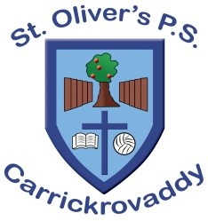 St Oliver’s Primary School, Carrickrovaddy
2 Roxborough Road
Cullyhanna, Newry,
BT35 0QJ
Tel: 028 30 878225
Website: www.stoliverspscarrickrovaddy.co.uk
Dear Parent or Guardian,
There has been a confirmed case of chickenpox in the school. If your child has not had chickenpox before it is quite likely that he/she may catch it.
What is chickenpox?
Chickenpox is a common childhood illness. Fever and cold symptoms are often the first signs of illness and are followed by the appearance of the typical rash. The rash starts as small pink bumps, often around the neck, ears, back and stomach. These develop a little water blister, which in turn becomes yellow and oozy and ultimately crusty as it dries. The rash spreads outwards to involve the whole body finally involving the lower arms and legs. People may have only a few spots or may be virtually covered with them. In children it is usually a relatively mild illness however occasionally complications develop.
What should I do now?
Chickenpox is likely to be a relatively mild illness and no specific precautions are necessary. Symptoms usually develop 10 to 21 days after exposure. The infected person can spread infection for up to three daysbefore the rash appears and until the last pox is crusted and dry.
What should I do if I think my child has chickenpox?
If you suspect your child has chickenpox, keep your child at home and ring your GP.
Can my child stay in school?
Many children with chickenpox are too unwell to attend school and are more comfortable at home. Children can spread the infection to others as long as there are any spots, which are not crusted and dried. The Public Health Agency recommends if your child has chickenpox you should inform their school or nursery and keep them at home while they are infectious. This is until the last blister has crusted over. This usually takes five or seven days after the rash begins. Children with spots that are crusted and dried can safely attend school.

