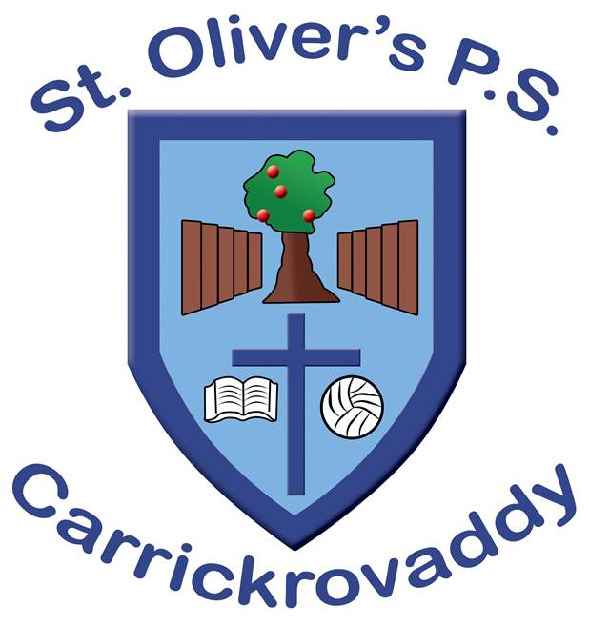
Assessment Policy

Assessment Policy

In St.Olivers Ps, through the breadth and balance of the Northern Ireland Curriculum, our pupils participate in a progression of learning experiences that are carefully structured to suit their needs.

In accordance to our mission and aims, we believe assessment is an integral part of the teaching and learning process. It enables us to recognise the talents and abilities of the individuals in our care and to plan to develop their potential, meet their individual needs and highlights the effectiveness of teaching and learning. It is then used to inform curriculum planning, the setting of children’s targets and the provision of resources.

Rationale
Assessment lies at the heart of the process of promoting children’s learning. It provides a framework within which educational objectives may be set and children’s progress expressed and monitored.
Research indicates that improving learning through assessment depends on five key factors:
- the provision of effective feedback to pupils;

- the active involvement of pupils in their own learning;

- adjusting teaching to take account of the results of assessment;

- a recognition of the profound influence assessment has on the motivation and self-esteem of pupils, both of which are crucial influences on learning;

- the need for pupils to be able to assess themselves and understand how to improve.

Aims of Assessment

Using the principles and processes of assessment we aim to:
to inform pupils, parents and teachers about individual progress and achievement within each class to monitor progress by highlighting strengths and identifying areas which need further attention

Aims
- to encourage children to become more involved in the work they do, that is, to promote approaches to self-assessment

- to use the results of assessments to assist teachers with future planning.

- evaluate levels of children’s learning against previous performance, personal ability and achievement by their peers.

- monitor progress and support learning through effective planning

- generate data which will track pupil progress over time

- provide information to ensure continuity when pupils change year group

- identify children who are gifted and/or talented
- identify children with special educational needs

- fulfill statutory requirements relating to assessment.

Types of assessment in St.Olivers Ps

Formative
So that positive achievements of pupils may be recognised and discussed and the appropriate steps planned.

Diagnostic
So that the strengths and weaknesses of the pupils may be identified and scrutinised and appropriate next steps taken.

Summative
So that the overall achievements of pupils may be recorded in a systematic way and at a particular time e.g. reporting to parents, end of key stage.

Evaluative
So that the information gained about pupil achievements may be used by schools to make curriculum planning and resource decisions.

Formative Assessment (Assessment for Learning – AfL)
Formative assessment is a powerful way of raising pupils’ achievement. It is based on the principle that pupils will improve most if they understand the aim of their learning, where they are in relation to this aim and how they can achieve the aim.

Formative assessments are used to:

- identify children’s strengths and gaps in their skills/knowledge
- identify next steps for learning
- inform future planning
- enable appropriate strategies to be employed
- facilitate the setting of appropriate targets for the class, group, and individual
- track the child’s rate of progress
- facilitate an evaluation of the effectiveness of teaching and learning
- inform future teaching and learning strategies
- identify individuals and groups for specific intervention support.

Summative Assessment - Assessment of Learning

- Summative assessment (Assessment of Learning) is important for informing both parents and teachers of a child’s attainment and progress. This will also inform whole school target setting and prediction of future attainment
- will identify attainment through one-off standardised tests at any given point in time
- record performance in a specific area on a specific date
- provide age standardised information
- provide end of key stage test data against which the school will be judged
- ensure statutory assessments at the end of KS1 and KS2 are met
- provide information about areas of strength and weakness to build from in the future

Assessment for Learning

- Assessment for Learning is the process of seeking and interpreting evidence for use by
- learners and their teachers to decide where the learners are in their learning, where they
- need to go next, and how best to get them there.’
- Assessment for Learning is a part of our normal teaching routine in St. Oliver’s.
- Assessment for Learning (AfL) places formative or continuous assessment at the heart of the learning and teaching cycle. The emphasis is on improvement, raising achievement in pupils' learning and celebrating success. AfL is conducted within day-to-day classroom practice and takes place during learning. It also gives pupils an active role in the assessment process.

- Assessment for Learning involves the following key actions:
- sharing learning intentions
- sharing and negotiating success criteria
- giving feedback to pupils
- effective questioning
- encouraging pupils to assess and evaluate their own and others’ work.

In St. Oliver’s, we recognise that peer and self-assessment and self-evaluation enables pupils to recognise success in their own and others’ work and to focus on how they are learning as well as what they are learning.

Analysis of Data
Effective use of GL Assessment Data

Pupils in years 2-7 are assessed in the third term each year using the GL Assessments,in English (PTE) and in Mathematics (PTM). Tests with their class teachers will be ongoing throughout the year. A Cognitive Ability Test (CAT) is used in P 4 and P6 to compare pupil outcomes against cognitive ability.

Role of Class Teachers
Class teachers identify children with lower or much lower than expected attainment and set in place remediation strategies
Class teachers use the GL Assessment online analysis to identify and target children.
Numeracy and Literacy targets are identified for each group of children. These targets and the educational plans inform the teaching & learning planning throughout the school year.

Identifies pupil strengths and areas for improvement and inform the next steps in planning, teaching and learning. All assessment can provide diagnostic evidence, however certain assessment tools can be particularly useful in providing more detailed data.
When a child is identified as having difficulty in any curricular area remedial action shall be planned and implemented. If in the judgement of the class teacher, in consultation with the SENCO, it is deemed necessary, a child may be placed on the schools special needs register. The procedures of the school special needs policy will then be invoked.

No child will be placed on the Special Needs Register without consultation with parents. However, it is essential to note that legally, school have an obligation to place a child on the Special Needs Register when they have identified their needs as requiring individualised support. Parents will always be kept fully informed and will form a vital part in the support of their child’s education.

Assessment for Learning

St.Olivers Ps upholds the aims of The Northern Ireland Curriculum Assessment for Learning for Key Stage 1 and 2 and demonstrates an ethos in which the personalities, strengths and needs of children are carefully considered and addressed individually. Through St Oliver’s commitment to Assessment for Learning (AFL) we aim to:
- improve performance
- increase learning independence
- improve morale, motivation and risk-taking
- enhance relationships and reflection

The assessment of children’s progress is an integral part of the cycle of teaching and learning. As a formative assessment, assessment for learning takes place during the learning and therefore gives pupils an active role in the assessment process. Assessment for learning enables teachers to judge the quality of learning against success criteria and to evaluate the need for further support, reinforcement or extension.
This ongoing cycle of assessment leads to an evaluation of teaching strategies and classroom management.

Assessment for Learning is monitored through the following:
- Marking for Improvement
- Verbal feedback/oral conversation with pupil
- WALT and WILF learning intentions and success criteria.
- Self-assessment through traffic lights/thumbs up strategy.
- KWL planning grids.
- Plenary opportunities.

Self-Assessment in St.Olivers PS

Pupils at St.Olivers Ps are involved in the process of self-assessment in which they comment on their work and that of their peers
Self- assessment enables our pupils to develop objectivity, raise self-esteem and encourages pride in their work.

Target Setting and Benchmarking.
Teachers set their own class and individual targets.
Reporting
Reporting to parents on children’s attainment is by:
- parent teacher meetings in Term One (October/November) where teacher inform parents of pupil progress.

- comments on written work, including homework.

- annual written reports – teacher will comment if a child is working below/ at/ or above their ability.

- in some cases, information from outside agencies.

- informal meetings.

Reporting to the Principal and teachers is by:
- class files containing test scores
- pupil files {cabinet in the office}
- staff meetings
- informal meetings
- teachers’ planners

Reporting to pupils on attainment is by:
- teacher comment on class work, both oral and written.
- Marking for Improvement opportunities.
- individual class reward schemes.

Marking
As a form of assessment, marking should be meaningful, informative and positive, providing an indication of a child’s achievement for both pupil and parent. The teacher’s professional judgement of children’s abilities, based on informal observations and on formal methods of assessment are an important sources of evidence in the monitoring process.

Standardised Tests
Standardised test results enable teachers to identify specific strengths and weaknesses and so plan for future teaching and learning. This evidence may also be used to provide information about the work of a particular pupil in order to ensure that sufficiently challenging goals are set or to indicate that the pupils name be placed on the Special Needs register if he/she requires support.

Monitoring and Evaluation
Assessment, recording and reporting procedure should be monitored annually in order that they remain meaningful and manageable. Policies and procedures may change in light of any new initiatives imposed and the school should respond to any such changes.

New Admissions
The ClassTeacher will employ appropriate assessment procedures to ensure that children work at their own level and in suitable groups. They will also use information forwarded by the previous school for new entrants or pupils transferring from another school.

Assessment for Pupils with Special Educational Needs
SEN pupils must complete Statutory Assessment PTM/PTE. Exemptions to this are pupils with Severe Learning Difficulties SLD and Profound and Multiple Learning Difficulties PMLD.

Temporary exemptions are at the principal’s discretion e.g. newcomer pupils, pupils with medical conditions and pupils suffering a traumatic experience.
SENCO to ensure teachers are aware of these exemptions.

Assessment Policy Review
This policy will be kept continually under review. It will be amended from time to time in accordance with the needs of the school.

